**DNS Log Analysis Using Splunk**Analyzing sample DNS Log data using SIEM tool SplunkDNS Log Ingestion  
  
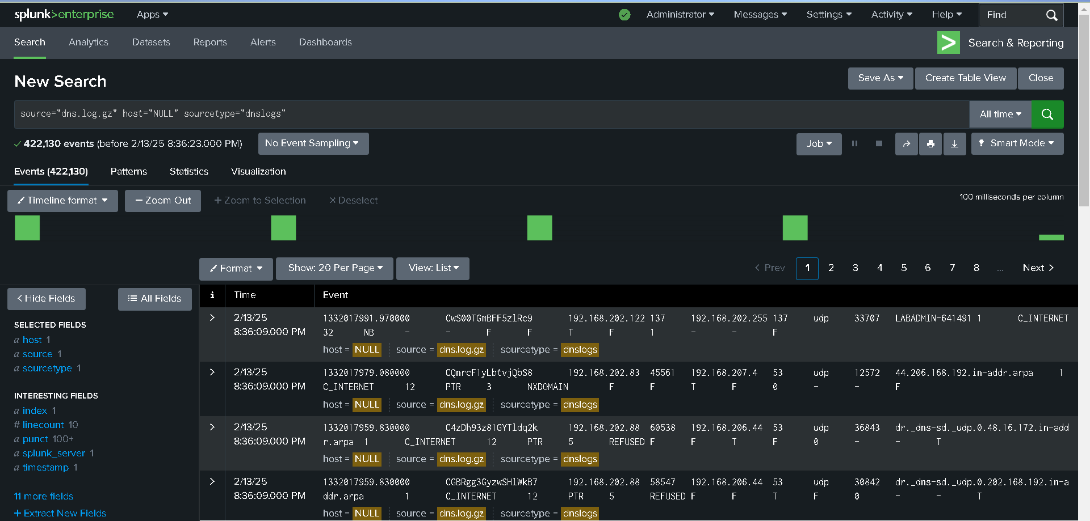  
  
Parsing the data by extracting new field  
  
selecting a sample event for extracting new field  
  
Choosing Regular Expression method  
  
Choosing 192.168.202.83 as source ip src_ip  
  
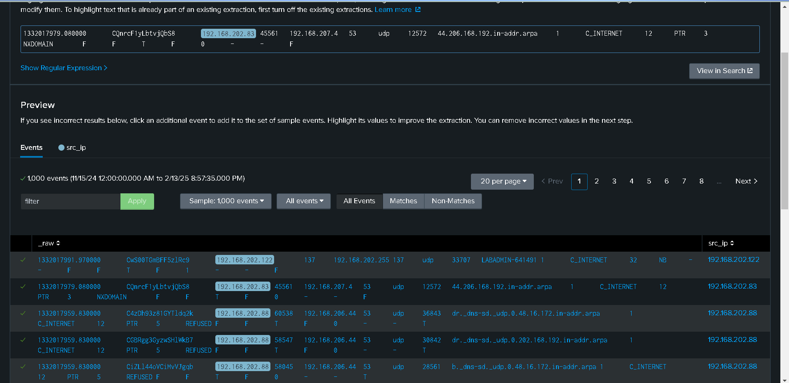

Selecting 45561 as source port src_port

Selecting 192.168.207.4 as destination ip dst_ip

And 53 the dns server port

44.206.168.192.in-addr.arpais the domain name

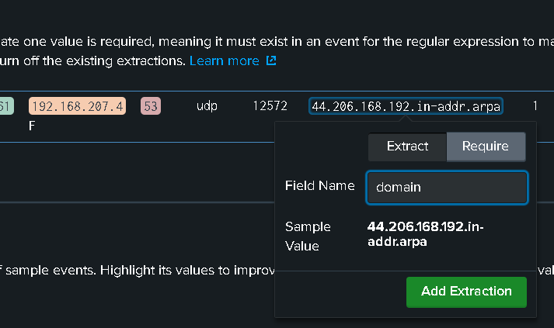

PTR - Type of record  
  
Successfully extracted the field from log

The extracted field lists are now on the interesting fields list

Stats count by domain name

Using top filter  
  
Now checking which source ip has requested more on specific domains  
  
From this we can suspect that 192.168.202.83 as the compromised machine  
  
  
  
  
Table view of source ip, destination ip and ports  
  
